# Kryptowire Jenkins Plugin Setup and Use

## Installation

To begin using the Kryptowire App Scanning Jenkins Plugin, it must first be installed into your Jenkins instance. To do this, select “Manage Jenkins” from your main page in Jenkins.­

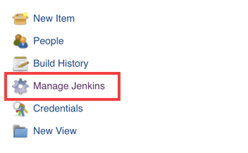

Figure Manage Jenkins

On this page, navigate to “Manage Plugins”.

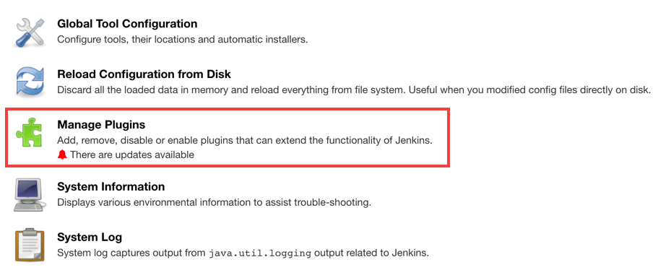

Figure Manage Plugins

On the Manage Plugins page, select the “Advanced” tab and then select the provided “.hpi” plugin file in the “Upload Plugin” section.

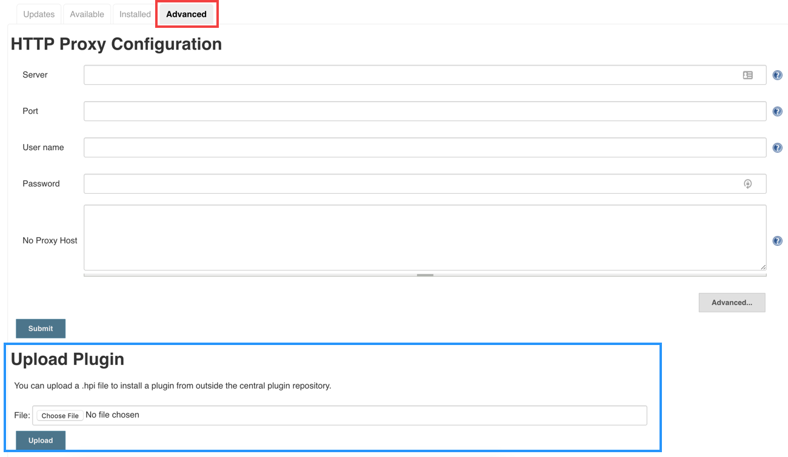

Figure Upload Plugin

After the plugin is uploaded and installed Jenkins will have to be restarted for the plugin to take effect.

## Configuration

After Jenkins is restarted, the plugin must be configured. Head back into the “Manage Jenkins” page and navigate to “Configure System”.

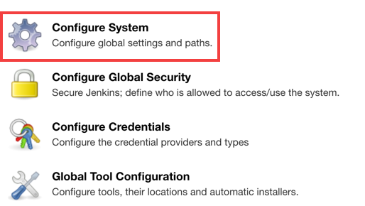

Figure Configure System

From here, scroll down the page until you see the “Kryptowire” configuration section. Here you will need to input your provided API key and API endpoint. Once those details are entered, you are ready to configure your build processes to include Kryptowire app scanning.



Figure Kryptowire Configuration

## Build Process Integration

The Kryptowire app submission can either be configured as a Build Step or as a step in a Pipeline.

For the Build Step configuration, navigate to your Jenkins project’s configuration page and scroll down to the Build section. Here you’ll click on “Add build step” and select “Submit to Kryptowire”. This build step must come after the step that creates the built application binary. In the Build Step configuration, you must select which platform the application you are building is for as well as the path to the application binary that is created by a previous Build Step.

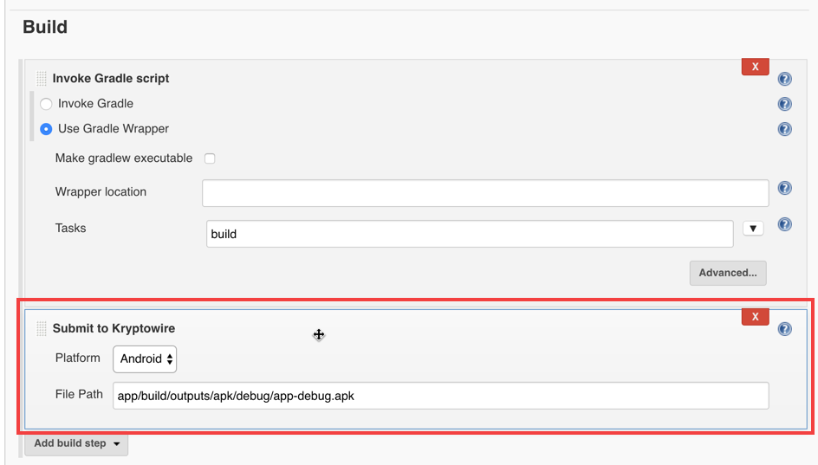

Figure Submit to Kryptowire

If you have a Jenkins process that utilizes a Pipeline, you can configure the Kryptowire app submission through that as well. In your Pipeline script configuration you can add a new step calling kwSubmit. This step takes two parameters of filePath (the relative path to the build application binary) and platform (which must be “ios” or “android”).

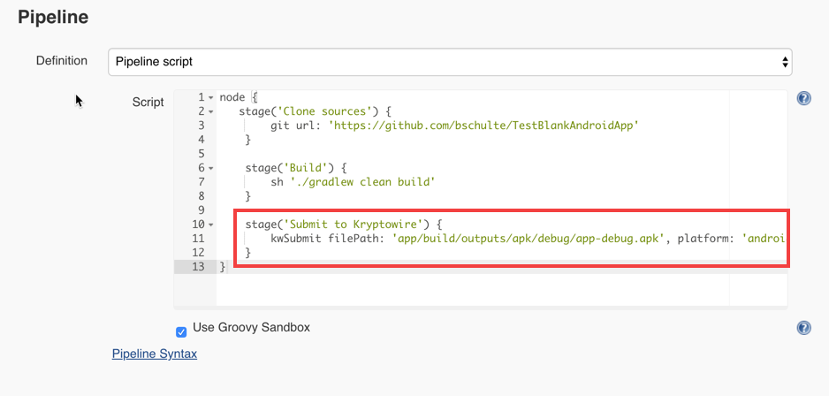

Figure Pipeline Configuration

## Viewing Scan Results

Once the build has been initiated, the app will be submitted for analysis. After analysis is complete, you can click on the “Kryptowire Scan Results” button in the individual build’s page to see the Kryptowire App Scan PDF reports.

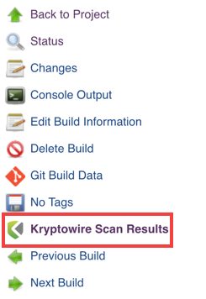

Figure Kryptowire Scan Results